**CSE1002 LAB FAT**

**20BDS0405 (Bimal parajuli)**

**Set 2.**

**C++ Vectors of Objects.**

**Algorithm to approach the given problem:**

Start

Define DailyTemp class:

Initiate a variable temp to store temperature 0 using default constructor.

Make a member function to getTemp and SetTemp

Overload operators == and < to check greater among multiple temperatures.

Main:

Make a vector of objects of DailyTemp Class.

Enter 7 temperatures one for each day

If necessary, compare and store the highest temperature in the vectors by calling pushback ()

Display all Fahrenheit temperatures in a line.

Convert and display all Celsius temperatures in a line**.**

End

**Code written in ‘Visual Studio Code’:** 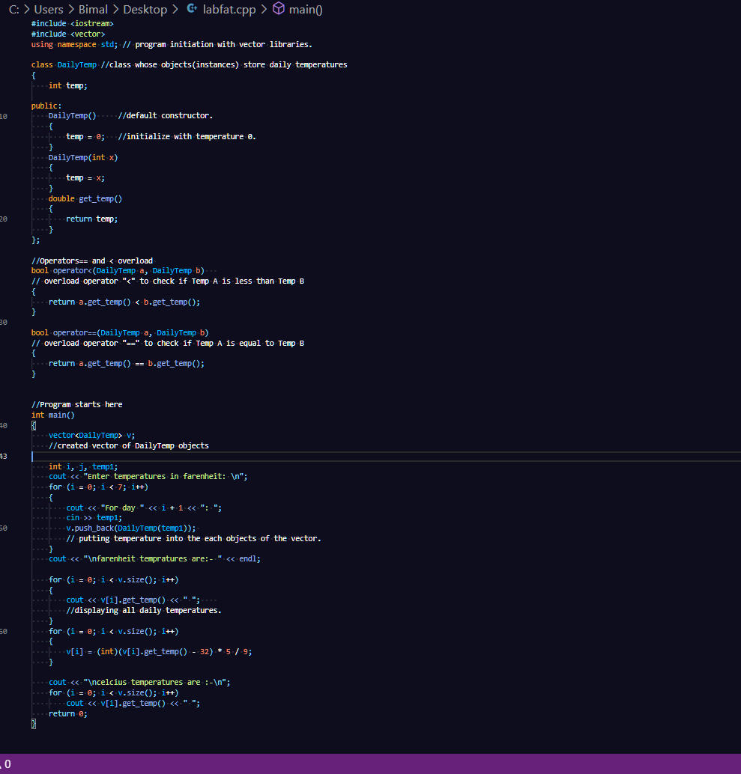

**Given Test Case passed:**

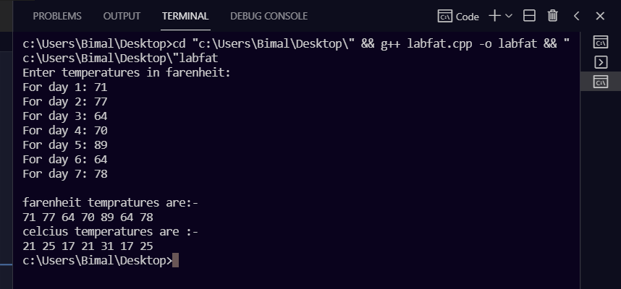

**Other multiple test cases tried and passed:**

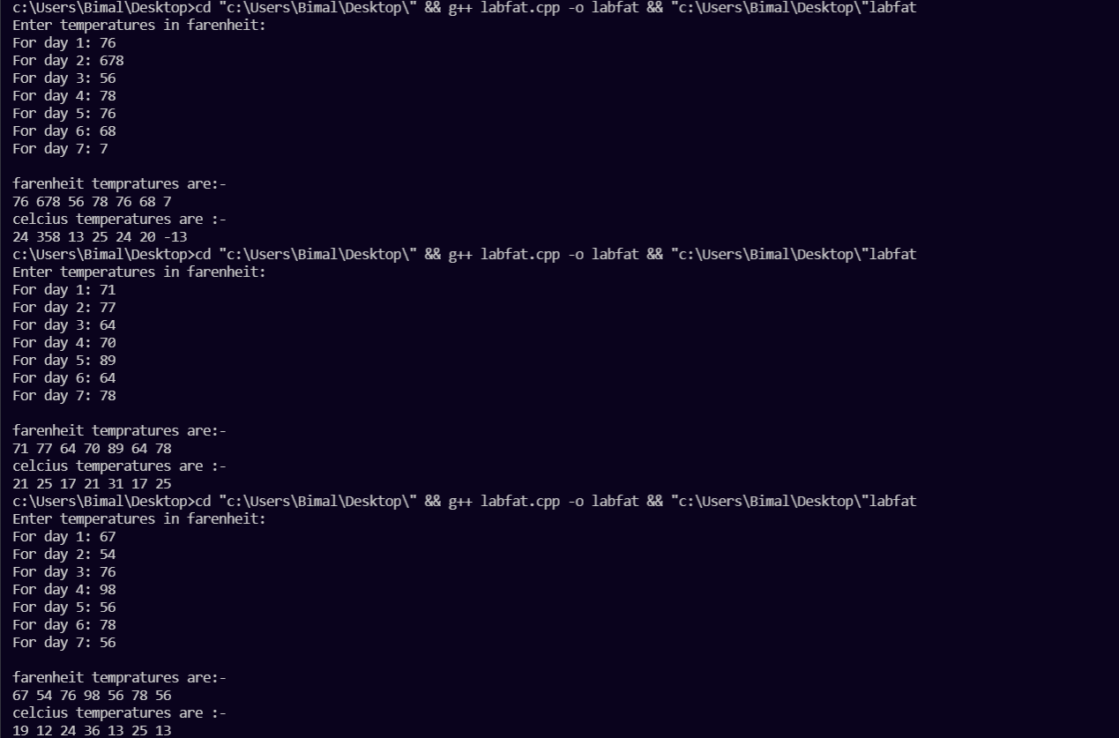

**End.**